Final Exam – EMBA 760 (Introduction to financial accounting)
Class EMBA #60 – Fall 2024
Nvidia & Wirtel Co.
10-24-24

Name: Brian Morman EMBA 60
Instructions:

- There are 6 parts to this exam. Be sure you have a complete exam. Read each problem carefully before beginning. This exam is open book, notes, library resources, etc.
- The primary purposes of this exam are to (1) reinforce the concepts covered during the course, (2) challenge you to continue to develop your accounting and business knowledge, and (3) provide an input to be used to assign a final grade in the course.
- You have two choices when completing this exam. These choices depend on whether you are pursuing the grade of ‘P’ (aka PASS) or the grade of ‘HP’ (aka HIGH PASS).
  - The following applies for students pursuing a ‘P’ in the course:
    - You must complete the parts identified as ‘P’ in Table 1 below.
    - You may seek “guidance” from others to help you over blockages. However, your solution is an individual task, with you alone being responsible for it.
  - The following applies for students pursuing an ‘HP’ in the course:
    - You must complete all parts of the exam as shown in Table 1 below.
    - You may NOT discuss the exam with anyone. All aspects of the exam are your responsibility alone.
- The Code of Conduct for the Olin School of Business applies, and you will need to sign a form on the next page indicating your understanding of these requirements. Provide full cites to all references used. Please contact the instructor if you have questions about the policy.
- Format for your solution: Please take care to (1) put your name on each page, (2) label each question clearly, (3) answer all the questions (but you can focus on parts that you believe will maximize your learning; but do communicate clearly which parts you focused on and which parts were not priorities for you), (4) present your solution in the proper order, and (5) staple the pages of your exam together. In sum, your exam should be organized and presented in a professional manner to enable assessment of your solutions.
- Citing your source: Be sure you cite all information sources that you rely on. It is critical that you do not copy and use any material without a complete cite to the source. You may use any format you prefer, but as some examples, see this site http://libguides.wustl.edu/citestyles for guidelines, Cite anytime you use AI.
- There are several files on Blackboard that you may wish to review prior to, or while you are completing the exam, including an Excel template file that you will need to use.

- See the next page for due dates.

- The firm that will be the primary focus of this exam is referred to as “THE FIRM” hereafter.
TABLE 1: OVERVIEW OF THE EXAM
Part # | Who must complete? | Topic(s) | Points
1 | P* | Analyst’s street-view of the FIRM | 15
2 | P | Expanded presentation of the FIRM’S financial statements (use the Excel spreadsheet on Blackboard) | 15
3 | P | EBITDA and analysis of the FIRM’S SCF | 15
4 | P | Ratio analysis of the FIRM’S financial statements | 15
5 | P | Pro forma financial statements – Wirtel, Inc. (this part of the exam is based on a stylized example - use the Excel spreadsheet on Blackboard) OR optionally, discuss how course did (or did not) affect the development of your business and/or professional skills | 15
6 | HP* | Earnings quality and preparation of forecasted / pro forma financial statements | 25
 |  | Total of 75 for ‘P’ and 100 for ‘HP’ students
* P indicates that all students must complete this part, and HP indicates additional requirement of students seeking an ‘HP.”

Name Brian Morman EMBA 60

The purpose of this page is for you to indicate.
- That the code of conduct applies and
- Whether you are pursuing a ‘P’ or an “HP.’.

- Please indicate below whether you are pursuing the grade of 'HP' or 'P' by signing the appropriate line below. If you do not submit a signed form, I will assume you are pursuing a ‘P.’
----------------------------------------------------------------------------------------------------------------------------------
For those pursuing a 'HP'
- I have completed all parts of the exam,
- I have not discussed the exam with anyone,
- I have not sought or received any help on any part of the exam. All aspects of the exam are completely my responsibility, and
- I have followed the EMBA code of conduct.

Sign here if you are pursuing a ‘HP.’
Sign here____________________________________________
----------------------------------------------------------------------------------------------------------------------------------
For those pursuing a 'P'
- I acknowledge that I can ask others (but not those in the class who are pursuing the grade of 'HP') for hints to get over blockages, but
- The write-up is my own responsibility alone. I have not received any aid beyond that of hints to get beyond blockages, and
- I have followed the EMBA code of conduct.

Sign here if you are pursuing a ‘P.’
Sign here: Brian Morman
----------------------------------------------------------------------------------------------------------------------------------
Please include this page when you submit your exam.

The firm that will be the primary focus of this exam is Nvidia. We will
refer to it as “THE FIRM” hereafter.
----------------------------------------------------------------------------------------------------------------------------------

Process for submitting final exams.
(1a) If you are hand delivering your final exam, please deliver it to:
Room 242 Simon Hall
Monday through Friday between the hours of 8:30am until 5:00pm.

(1b) If you are mailing your final exam, please use the following address.

Washington University in St. Louis
Olin Business School
ATTN: Ron King Acct 760 Final exam
One Brookings Drive
MSC 1133-124-242
St. Louis, MO 63130-7603

Due date of final exam = Monday 11/11/24 End of day

Name: Brian Morman EMBA 60
Part 1: Analyst’s street-view of the FIRM
Suggested length: 2 – 3 pages:

Prepare an analyst street-view of the FIRM. The goal of the street-view is to organize the relevant information as an analyst would in order to have a framework to succinctly communicate the core aspects of the FIRM.

NVIDIA is headquartered in Santa Clara, California. They were originally incorporated in Californica in April 1993 and reincorporated in Delaware in April 1998. At their core NVIDIA is an accelerated computing company who holds a unique position in their industry as a high-end Integrated Circuit (IC) designer and full stack computing infrastructure company. This means that they create cutting edge hardware, host device software through their CUDA programming model, and offer data center solutions to scale accelerated computing to the enterprise level. The firm splits their primary business into two segments: The Compute and Networking Segment and the Graphics segment. NVIDIA has a corporate presence in six continents and ~ 30k employees as of January 2024. Their annual report points out that over half their engineers work on software to reflect their unique value to the IC industry. The image below shows how NVIDIA’s hardware pairs with the CUDA software model to fill demand from several industries.

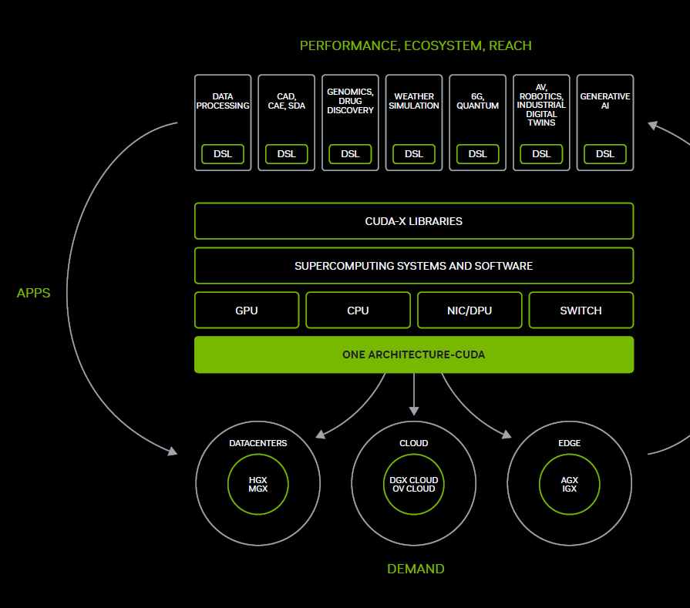
Graphic 1: NVIDIA Ecosystem Model – NVIDIA Annual Report

Per Yahoo Finance (http://finance.yahoo.com/), the firm reports revenue of 96.31B (ttm 9/24), total cash 34.8B (mrq), a return on Assets of 55.26% and EBITDA of 39.67B. As noted in the Annual report for NVIDIA, “2024 was an extraordinary year”. In their business overview they note these key metrics: revenue up 126% year on year (yoy), gross margin up 72.7% yoy, operating income up 681% yoy, and diluted earnings per share up 586% yoy to $11.93. The graphic below from Yahoo Finance shows NVIDIA’s astronomical rise in market value from 2023 into 2024 primarily driven by the success of the NVIDIA Hopper GPU platform and growth of Large Language Models (LLM’s) and generative AI usage worldwide.
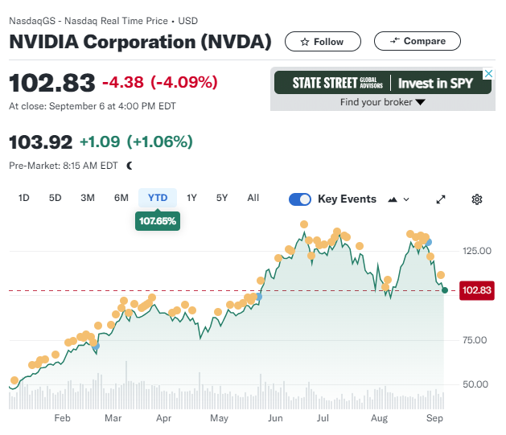
Graphic 2: NVIDIA Corporation Stock Price Year to Date – Yahoo Finance

Per Yahoo Finance, NVIDIA is a part of the Semiconductor Industry within the Tech sector. Within this sector, NVIDIA splits their efforts into two reportable segments: Compute and Networking and Graphics. The graphic below shows the major industries in which NVIDIA’s product offering is utilized along with revenue info to show just how successful 2024 was for NVIDIA. This graphic comes from the 2024 NVIDIA Annual Report.

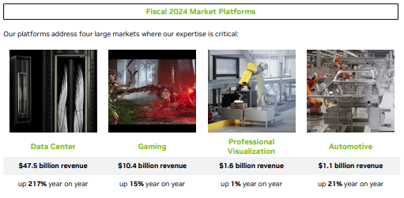
Graphic 3: NVIDIA Market Platforms and Revenue – NVIDIA Annual Report

NVIDIA got their start as a gaming and graphics compute hardware company but the graphic above and the CEO’s letter to shareholders highlights the growth in Data Centers needed to support growing use of generative AI that make this sector by far their most valuable product offering for the near future.

NVIDIA currently has a substantial lead in their market amongst competitors: Advanced Micro Devices (AMD), Huawei Technologies Co. LTD (Huawei), and Intel Corporation (Intel). They have the most differentiated product in their market for GPU processors used in data centers for AI compute. But the competition will be racing to catch up and provide a more competitive product. There is no doubt these competitors have the brain power needed to rebalance the competition over time. Outside of innovation, the competition in this space will be fought in relationships to critical customers and suppliers. For NVIDIA, it is important to recognize that 19% of their total revenue comes from Microsoft. In some ways this ties NVIDIA’s continued success to the success of that critical customer. On the supply side, the landscape is complicated and intertwined with geopolitics that are predicted to get more and more complicated in the future. The leading supplier of silicon wafers in the world comes from Tiwan Semiconductor Manufacturing who lead the industry substantially with the processes they can offer that make NVIDIA’s product offering manufacturable. Other suppliers are again working to compete in this space with TSMC but for now that Asia-Pacific centric supplier is the industry leader that is critically tied to NVIDIA’s success.
NVIDIA will continue to innovate in this space, but the value of their recent innovation cannot be replicated again in the near future. Innovation in semi-conductor manufacturing has been tracked using a theory called Moore’s law. Moore’s law reflects an observation that the number of transistors on producible integrated circuits has doubled every two years since 1970. This has led to a continued boom in the semiconductor and computing industries for decades. 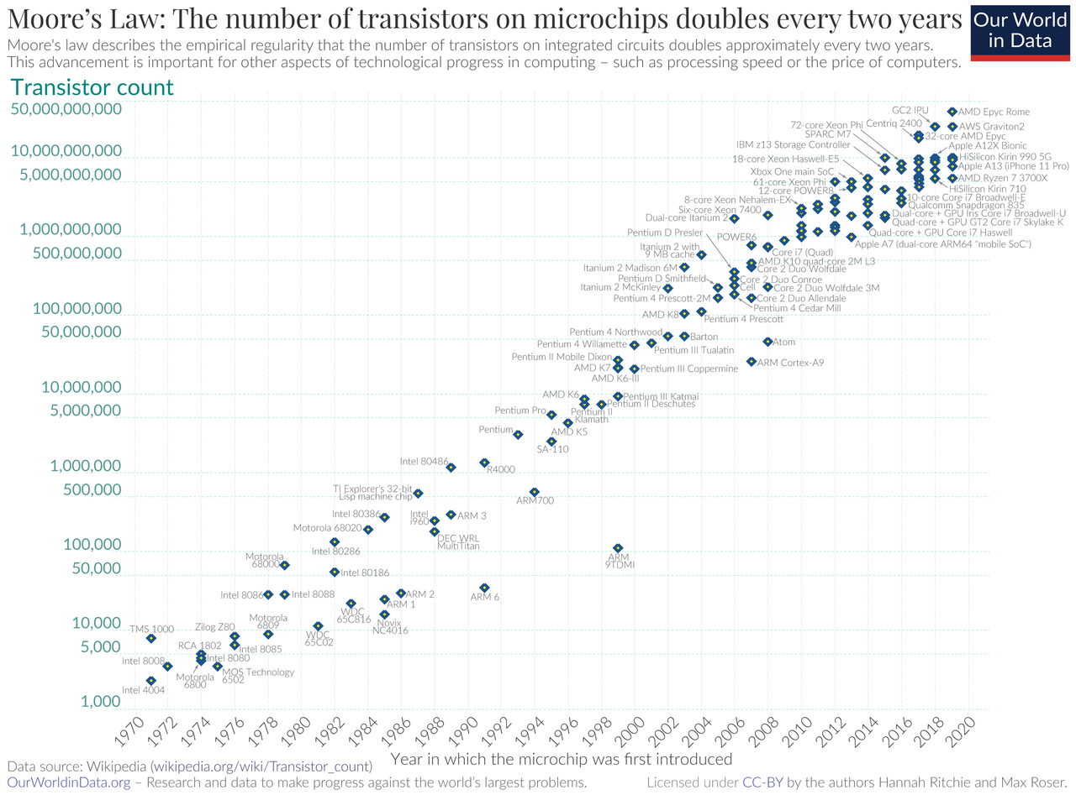
Graphic 3: Moore’s Law – Wikipedia

Moore’s law at a very basic level tells us that computers will get 2x faster or smarter every two years. NVIDIA’s GPU innovation allows for a 10x improvement in computer performance that blows Moore’s law out of the water. This surge in processing capability hasn’t been seen in decades and will not be repeated soon. To an analyist this can show NVIDIA’s massive growth could slow. From here the question is how does the customer base grow and change as the world learns how to utelize this technological change.

Name: Brian Morman EMBA 60

Part 2: Expanded presentation of the financial statements

Use the Excel template on Blackboard to prepare the expanded presentation for THE FIRM’s
- Income statements
- Balance sheets

NVIDIA Corporation and Subsidiaries |  |  | See Chapter 6, Topic 6 of Financial Reporting: First Take for discussion of Expanded presentation
Consolidated Balance Sheets
(In millions, except par value)
 | Jan 28, 2024 | Jan 29, 2023
Assets |  |  | $ change for two years | % change for two years |  | common-sized for 2024 |  | common-sized for 2023
Current assets:
Cash and cash equivalents | $ 7,280 | $ 3,389 | $ 3,891 | 114.81% |  | 11.08% |  | 8.23%
Marketable securities | 18,704 | 9,907 | $ 8,797 | 88.80% |  | 28.46% |  | 24.06%
Accounts receivable, net | 9,999 | 3,827 | $ 6,172 | 161.28% |  | 15.21% |  | 9.29%
Inventories | 5,282 | 5,159 | $ 123 | 2.38% |  | 8.04% |  | 12.53%
Prepaid expenses and other current assets | 3,080 | 791 | $ 2,289 | 289.38% |  | 4.69% |  | 1.92%
Total current assets | 44,345 | 23,073 | $ 21,272 | 92.19% |  | 67.47% |  | 56.03%
Property and equipment, net | 3,914 | 3,807 | $ 107 | 2.81% |  | 5.95% |  | 9.24%
Operating lease assets | 1,346 | 1,038 | $ 308 | 29.67% |  | 2.05% |  | 2.52%
Goodwill | 4,430 | 4,372 | $ 58 | 1.33% |  | 6.74% |  | 10.62%
Intangible assets, net | 1,112 | 1,676 | $ -564 | -33.65% |  | 1.69% |  | 4.07%
Deferred income tax assets | 6,081 | 3,396 | $ 2,685 | 79.06% |  | 9.25% |  | 8.25%
Other assets | 4,500 | 3,820 | $ 680 | 17.80% |  | 6.85% |  | 9.28%
Total assets | $ 65,728 | $ 41,182 | $ 24,546 | 59.60% |  | 100.00% |  | 100.00%
 |  |  | $ - | #DIV/0! |  | 0.00% |  | 0.00%
Liabilities and Shareholders' Equity |  |  | $ - | #DIV/0! |  | 0.00% |  | 0.00%
Current liabilities: |  |  | $ - | #DIV/0! |  | 0.00% |  | 0.00%
Accounts payable | $ 2,699 | $ 1,193 | $ 1,506 | 126.24% |  | 4.11% |  | 2.90%
Accrued and other current liabilities | 6,682 | 4,120 | $ 2,562 | 62.18% |  | 10.17% |  | 10.00%
Short-term debt | 1,250 | 1,250 | $ - | 0.00% |  | 1.90% |  | 3.04%
Total current liabilities | 10,631 | 6,563 | $ 4,068 | 61.98% |  | 16.17% |  | 15.94%
Long-term debt | 8,459 | 9,703 | $ -1,244 | -12.82% |  | 12.87% |  | 23.56%
Long-term operating lease liabilities | 1,119 | 902 | $ 217 | 24.06% |  | 1.70% |  | 2.19%
Other long-term liabilities | 2,541 | 1,913 | $ 628 | 32.83% |  | 3.87% |  | 4.65%
Total liabilities | 22,750 | 19,081 | $ 3,669 | 19.23% |  | 34.61% |  | 46.33%
Commitments and contingencies - see Note 13 |  |  | $ - | #DIV/0! |  | 0.00% |  | 0.00%
 |  |  | $ - | #DIV/0! |  | 0.00% |  | 0.00%
Shareholders' equity: |  |  | $ - | #DIV/0! |  | 0.00% |  | 0.00%
Preferred stock, $0.001 par value; 2 shares authorized; none issued | - | - | $ - | #DIV/0! |  | 0.00% |  | 0.00%
Common stock, $0.001 par value; 8,000 shares authorized; 2,464 shares |  |  | $ - | #DIV/0! |  | 0.00% |  | 0.00%
issued and outstanding as of January 28, 2024; 2,466 shares issued and |  |  | $ - | #DIV/0! |  | 0.00% |  | 0.00%
outstanding as of January 29, 2023 | 2 | 2 | $ - | 0.00% |  | 0.00% |  | 0.00%
Additional paid-in capital | 13,132 | 11,971 | $ 1,161 | 9.70% |  | 19.98% |  | 29.07%
 |  |  | $ - | #DIV/0! |  | 0.00% |  | 0.00%
Accumulated other comprehensive income (loss) | 27 | (43) | $ 70 | -162.79% |  | 0.04% |  | -0.10%
Retained earnings | 29,817 | 10,171 | $ 19,646 | 193.16% |  | 45.36% |  | 24.70%
Total shareholders' equity | 42,978 | 22,101 | $ 20,877 | 94.46% |  | 65.39% |  | 53.67%
Total liabilities and shareholders' equity | $ 65,728 | $ 41,182 | $ 24,546 | 59.60% |  | 100.00% |  | 100.00%

NVIDIA Corporation and Subsidiaries
Consolidated Statements of Income
(In millions, except per share data)
 |  | Year Ended
 | Jan 28, 2024 | Jan 29, 2023 | Jan 30, 2022
Revenue | $ 60,922 | $ 26,974 | $ 26,914
Cost of revenue | 16,621 | 11,618 | 9,439
Gross profit | 44,301 | 15,356 | 17,475
Operating expenses
Research and development | 8,675 | 7,339 | 5,268
Sales, general and administrative | 2,654 | 2,440 | 2,166
Acquisition termination cost | - | 1,353 | -
Total operating expenses | 11,329 | 11,132 | 7,434
Operating income | 32,972 | 4,224 | 10,041
Interest income | 866 | 267 | 29
Interest expense | (257) | (262) | (236)
Other, net | 237 | (48) | 107
Other income (expense), net | 846 | (43) | (100)
Income before income tax | 33,818 | 4,181 | 9,941
Income tax expense (benefit) | 4,058 | (187) | 189
Net income | $ 29,760 | $ 4,368 | $ 9,752
Net income per share:
Basic | $ 12.05 | $ 1.76 | $ 3.91
Diluted | $ 11.93 | $ 1.74 | $ 3.85

See Chapter 7, Topic 12 of Financial Reporting: First Take for discussion of Expanded presentation and formulae
$ change for |  | % change for |  | $ change for |  | % change for |  | common-sized for |  | common-sized for |  | common-sized for
2024 v 2023 |  | 2024 v 2023 |  | 2023 v 2022 |  | 2023 v 2022 |  | 2024 |  | 2023 |  | 2022
$ 33,948.00 |  | 125.85% |  | $ 60.00 |  | 0.22% |  | 100.00% |  | 100.00% |  | 100.00%
$ 5,003.00 |  | 43.06% |  | $ 2,179.00 |  | 23.09% |  | 27.28% |  | 43.07% |  | 35.07%
$ 28,945.00 |  | 188.49% |  | $ (2,119.00) |  | -12.13% |  | 72.72% |  | 56.93% |  | 64.93%
$ 1,336.00 |  | 18.20% |  | $ 2,071.00 |  | 39.31% |  | 14.24% |  | 27.21% |  | 19.57%
$ 214.00 |  | 8.77% |  | $ 274.00 |  | 12.65% |  | 4.36% |  | 9.05% |  | 8.05%
$ (1,353.00) |  |  |  | $ 1,353.00 |  |  |  |  |  | 5.02%
$ 197.00 |  | 1.77% |  | $ 3,698.00 |  | 49.74% |  | 18.60% |  | 41.27% |  | 27.62%
$ 28,748.00 |  | 680.59% |  | $ (5,817.00) |  | -57.93% |  | 54.12% |  | 15.66% |  | 37.31%
$ 599.00 |  | 224.34% |  | $ 238.00 |  | 820.69% |  | 1.42% |  | 0.99% |  | 0.11%
$ 5.00 |  | -1.91% |  | $ (26.00) |  | 11.02% |  | -0.42% |  | -0.97% |  | -0.88%
$ 285.00 |  | -593.75% |  | $ (155.00) |  | -144.86% |  | 0.39% |  | -0.18% |  | 0.40%
$ 889.00 |  | -2067.44% |  | $ 57.00 |  | -57.00% |  | 1.39% |  | -0.16% |  | -0.37%
$ 29,637.00 |  | 708.85% |  | $ (5,760.00) |  | -57.94% |  | 55.51% |  | 15.50% |  | 36.94%
$ 4,245.00 |  | -2270.05% |  | $ (376.00) |  | -198.94% |  | 6.66% |  | -0.69% |  | 0.70%
$ 25,392.00 |  | 581.32% |  | $ (5,384.00) |  | -55.21% |  | 48.85% |  | 16.19% |  | 36.23%
$ 10.29 |  | 584.66% |  | $ (2.15) |  | -54.99% |  | 0.02% |  | 0.01% |  | 0.01%
$ 10.19 |  | 585.63% |  | $ (2.11) |  | -54.81% |  | 0.02% |  | 0.01% |  | 0.01%

Subpart A:
2A.1: Complete the expanded presentation for the FIRM’S income statements (using the Excel template).
- Then, cut and paste the completed expanded presentations into this document and
- provide answers to the following questions.

2.A.2: Interpret the expanded income statements. You should discuss those items from the FIRM’s income statement that you think are most important. Examples include, but are not limited to
- A discussion of any particular line item (such as operating earnings) and search the annual report to read about this line item and summarize your findings,
- gross margin percentage,
- operating income percentage,
- tax rate,
- net income,
- changes in these measures over time,
- and any other trends or aspects of this financial statement that you think might be of interest to financial analysts.

There are multiple lines on NVIDIA’s Income statement that jump off the page from their incredible fiscal year. From ’22 to ’23 NVIDIA grew revenue by 100.22% then improved substantially on that trend booming another 225.85% in ’24. While increasing revenue they also grew gross margin which multiplies that growth down to the bottom line. With revenue growth and gross margin growth, NVIDIA’s product offering shows to be dominant. They were able to sell more and at greater profit margins showing how differentiated their product really is. NVIDIA’s SG&A has remained steady throughout this boom which is one more thing that points to the sustainability of this revenue boom. They aren’t needing to increase their costs to sell more. They are running lean and outperforming their competition to win without spending cash to do so. Operating income is one number that really jumps off the page in this income statement since NVIDIA’s growth in this area was 591% from ’23 to ’24. Given this kind of astronomical growth its important then to ask, is the entire industry this bullish? Macrotrends shows growth in the semiconductor industry of ~50%. This is a massive increase in any industry, but NVIDIA is by far the top performer in the space, and they contribute to a large chunk of this growth. With a gross margin of 73% NVIDIA is a top performer in and industry that is experiencing a boom and appear capable of retaining that spot for the foreseeable future. To anticipate where NVIDIA will go next it will be critical to keep an eye on Intel who is their legacy competition. Intel has dominated this industry for decades and intends to invest to win back their share of the market space. It remains to be seen if Intel can create a competitive product in the near future.

2.A.3: Compute THE FIRM’S P/E for the two most recent annual report dates.
 | Most recent year | Previous year
Number of shares of common stock outstanding | 24,530,000,000 | 24,700,000,000
Diluted EPS for the year ending | 1.19 | 0.17
Price per common share of common stock | $61.20 | $19.16
P/E ratio (Using diluted EPS) | 51.28 | 112.71

2.A.4: What do you learn from these P/E ratios and the changes in the ratios across these two dates?
The price to earnings ratio is a commonly used metric to measure a company’s performance. It tells us the ratio of stock price or assumed value compared to financial performance. A low margin would show the market is betting on reduced performance or over inflated earnings that aren’t expected to last and a high P/E ratio shows the market is betting good financial performance is expected to continue.
NVIDIA’s P/E ratio is extremely high. The market is showing a high level of belief in NVIDIA’s continued financial success. That said, this ratio is much higher than normal. NVIDIA’s stock price has soared as a result of their financial success and media hype. All financial indicators show that NVIDIA will continue to report good financials for years to come but this P/E still shows a threat of a bubble. The stock valuation greatly outweighs the firm’s actual financial performance even in their impressive financial year. The delta between 2024 and 2023 points to the undervaluation of NVIDIA stock in 2023 before the surge in their valuation came from new product releases in 2023 and the hype around AI data processing.
Name: Brian Morman EMBA 60

Subpart B:

2B.1: Complete the expanded presentation for the FIRM’S balance sheets (using the Excel template).
- Then, cut and paste the completed expanded presentations into this document and
- provide answers to the following questions.

2.B.2: Interpret the expanded balance sheets. You should discuss those items from the balance sheet that you think are most important. Examples include, but are not limited to.
- A discussion of any particular line item (such as goodwill) and search the annual report to read about this line item and summarize your findings,
- liquidity and changes over the two years,
- capital structure and changes over the two years,
- mix of assets and changes over the two years,
- and any other trends or aspects of this financial statement that you think might be of interest to financial analysts.
NVIDIA carries a current asset to total assets of 67.47% which gives us a quick metric for NVIDIA’s liquidity (how much of their total assets are available as working capital). This ratio is a metric of financial health and is a perfectly acceptable number for a firm to report. Especially given that NVIDIA is in the semiconductor industry which is particularly capital heavy and require a great deal of long-term investment. NVIDIA’s strategy will be growth heavy since their dominant technology is fairly immature. For this reason, it makes sense that despite their current financial success they are still heavily invested in future growth resulting in a CATA that is good but not great. When reviewing NVIDIA’s long-term assets, it’s interesting that there has been a 20.8% change in their investment in software and only a 13.6% increase in their PP&E. This stands out because we tend to think of NVIDIA as a hardware firm but as their annual report points out, NVIDIA also sells a software enterprise that utilizes their hardware effectively. This is a space NVIDIA clearly plans to grow in. Another interesting note is the 50% reduction in construction in progress. This shows that NVIDIA has completed a significant portion of their new construction of PP&E. This will inevitably show up as increased revenue in their balance sheet in the future. Total liabilities to total assets are a ratio that shows how much of a company’s assets are financed by debt. This can tell a lender how likely a company is to weather financial crisis or the occurrence of any of the big risk items a Firm may list in their Annual Report. For example, a low debt to asset ratio would show that if cash flow were to slow down, the company would be able to weather that change because they own more than they owe. For NVIDIA, this metric shows that their growth is largely self-funded. It reflects, when combine with their revenue, that NVIDIA’s investments in the future are not reliant on debt or loans. This ratio tells lenders that NVIDIA is a relatively safe company to lend money to and boosts their leverage in loan negotiations which would enable them to get more favorable loans. From 2024 to 2023, NVIDIA’s retained earnings increased by 193.2%. This increase comes from the massive growth in revenue NVIDA has seen in 2024 and helps to explain their stock price increase in that same time. NVIDIA’s biggest line growths are below along with their explanations: Total Investments and Advances: 417% - Reflects NVIDIA’s investment in revenue growth for the future and the tech boom NVIDIA is predicting.
Work in Progress Inventory 223% - This shows expanded production capacity or reduction in throughput potentially. Finished goods has reduced and revenue is up so I take this to primarily reflect increased manufacturing capacity.
Miscellaneous Current Assets: 298% - misc. current assets (MCA) can include cash advances, cash with restricted use, or other minor things. This rate of change being as big as it is requiring me to include it here though it’s hard to determine the cause. Knowing the semiconductor industry, it is likely that a significant portion of this is restricted cash due to advances or risk release purchases placed to a supplier. Electronic components can have tremendously long lead times over the last five years. My estimation is that NVIDIA may have significant cash tied up to secure shorter lead times on some of the parts the critically need as promises to pay on delivery of items that may have leads as long as 52 weeks.
Total Accounts Receivable 161% - Shows an influx in cash from top line growth.
Deferred Income – 163% - This increase in deferred income shows the flip side of the issue described under MCA above. Since NVIDIA is a semiconductor manufacturer, they likely have risk release purchase agreements with customers as well to secure shortened lead times. In some of these cases the cash may be paid to NVIDIA in advance which is why it shows up under liabilities rather than assets. It reflects a promise of delivery yet to be fulfilled that must be subtracted from the assets to properly reflect total equity.
Retained Earnings 193% this metric reflects a high level of investment in future growth.
2.B.3: Compute the P/B ratio for THE FIRM for the two most recent annual report dates.
 | Previous year | Most recent year
Number of shares of common stock outstanding | 24530000000 | 24,700,000,000
Price per share of common stock | $61.20 | $19.16
Total value of common equity | $2,651,693,000,000.00 | $1,125,579,000,000.00
Total book value of shareholders’ equity (millions) | $42,978 | $22,101
Book value per share | $1.75 | $0.89
P/B ratio | 61.69884592 | 50.928872

2.B.4: What do you learn from these P/B ratios and the changes in the ratios across these two dates?
The price to book ratio reflects error in market valuation of a stock. It tells potential investors if a stock’s price is too high, too low, or just right compared to the company’s financial position. At its core the P/B ratio tells the investor how much the rock-bottom value of their stock is, or how much cash they would be entitled too if the company were to cease to exist. A stock with a P/B value <1 would show an undervalued stock while a value >1 says that a company is worth more than just its total assets. A mature company like NVIDIA would be very unlikely to have a P/B ratio near one. A P/B ratio as high as NVIDIA’s is possible only by firm that is seen as financial stable and likely to continue to grow.

NVIDIA’s P/B growth comes from an increase in energy and excitement around the company’s product offering and lots of speculation of continued growth. NVIDIA’s very successful 2024, the growing buzz around AI computing and the tech boom it enables have all drawn investors to conclude the company is worth more than its current assets.

Name: Brian Morman EMBA 60

Part 3: Use THE FIRM’s financial statements to complete the following.

Subpart A:
2.A.1: Compute EBITDA for the most recent year (show your calculations). Show the formula and explain why you used this formula.

$$EBITDA=NI+Interest+Taxes+Depreciation+Amortization$$

$$EBITDA \left(millions\right)=\$29,760+\$866-\$257+\$1,508=\$31,877$$
EBITDA is earnings before interest, taxes, depreciation and amortization. To calculate EBIDTA, we take the bottom-line net income from the income statement and add back in the other terms in our above equation. We use EBITDA as a way to understand a firm’s profitability that removes managerial assumptions and allows firms to be more directly compared.

3.A.2: Compute Free Cash Flow (FCF). Show the formula and explain why you used this formula.

$$FCF=CFO+Net Interest Expense-CapEX$$
$$FCF(millions)=\$23,572=\$28,090+\$866-\$257-\$1,069$$
Free cash flow is a calculation of cash available to pay debts, make investments, pay dividends, or otherwise utilize their available cash. To calculate FCF we take the cash from operations, subtract interest expenses, add back the tax shield value of that interest expense, then subtract capital expenditures. For NVIDIA, CAPEX comes from the cash flow statement and is called out as “Purchases related to property and equipment and intangible assets”.

3.A.3: Discuss and interpret your EBITDA and the FCF calculations. Which do you think is more informative for an investor? Why?

EBITA and FCF are both measures of financial performance that attempt to give a clear picture of just how profitable a firm really is. Both measures are valuable in their own right. It goes to the analyst to determine when to use each measure. FCF has fewer terms in its calculation and is somewhat harder to manipulate. It also takes a more wholistic view of a firm’s financials while EBITDA ignores several factors that do impact profitability. Taxes really cannot (or should not ) be ignored. But EBIDTA does a better job of common sizing a firm’s profitability across industries and makes it easier to compare performances. As a final note, EBITDA is the better measure to use when a firm has taken on a large amount of recent debt. A merger, acquisition, or other large capital expenditure can really skew a firm’s yearly financials in a way that can only be assessed in EBITDA since they won’t be reflected in CFO.
Subpart B:
3.B: Analyze THE FIRM's cash flows for the three years shown by discussing each of the three major sections. You can find the statements in the FIRM’s annual report. In addition, the FIRM provides a discussion of the cash flow in its annual report.

3.B.1: Discuss what you learn from the CFO section of the FIRM’S statement of cash flows

From CFO, we see: NVIDIA’s net income is trending upward with an average YoY increase of $27.4M The greatest increase comes from FY2024 which posted more than six times the Net income of the previous year.
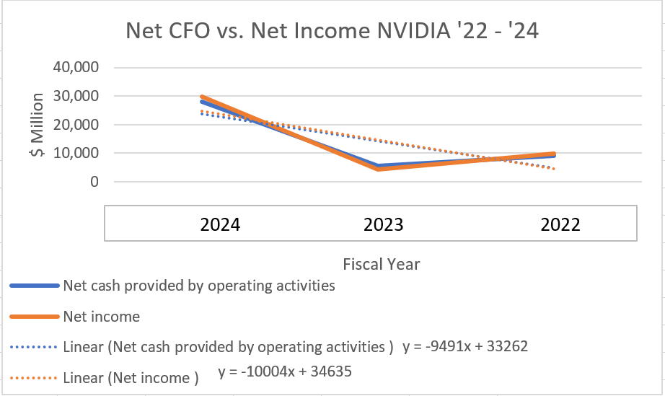

Cash flow from operations does not have a true trend over this three-year period but the massive growth in CFO in 2024 shows NVIDIA’s CFO is likely beginning a very positive trend. The R^2 value of this trend line is nearly 50 which shows there is not an accurate fit to the trend, but it is interesting to see how closely Net Income matches CFO on this plot. For 2024 and 2022 net income is greater than CFO. In both years this delta can be contributed to a positive difference between cash used in investing and cash provided by financing. With NVIDIA’s financial history it’s understandable that they would be able to generate a lot of CFF as a very attractive investment for financial organizations Again high R^2 fit for this plot shows there is no linear fit but in general the large increase from ’23 into ’24 comes from the new technology NVIDIA has created that is generating massive operating revenue and increasing interest from lenders.

3.B.2: Discuss what you learn from the CFI section of the FIRM’S statement of cash flows

These three years of data show no trend in CFI. Interestingly, NVIDIA generated more cash from investments in 2023 than they used. This delta comes from a very high year in proceeds from marketable securities.

NVIDIA’s CFS mixes CapEx with expenses towards intangible assets and depreciation with amortization which makes it impossible to divorce those two. In 2022 and 2024 capital expenditures were less than D&A. This delta implicates that NVIDIA is a mature company. But in 2023 the ratio is flipped, this shows that NVIDIA is also still growing as result of their technical evolution in recent years. In all three fiscal years, NVIDIA’s CFO was greater than their CFI.

3.B.3: Discuss what you learn from the CFF section of the FIRM’S statement of cash flows

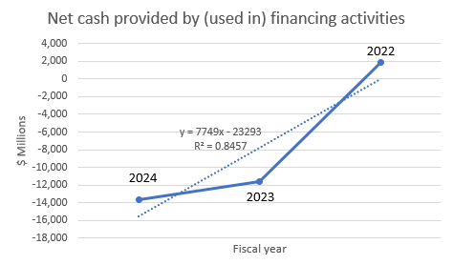
With a fairly low fit, the trend for cash flow from financing is showing a negative trend. This change is overwhelmingly driven by repurchases of common stock during 2023 and 2024.
Per NVIDIA’s 2024 balance sheet, they hold liabilities of: 1.2B short term debt, 8.5B in long term debt, and 42.9B in shareholder equity. With investor confidence so high it makes sense that NVIDIA is able to rely far more heavily on equity financing.
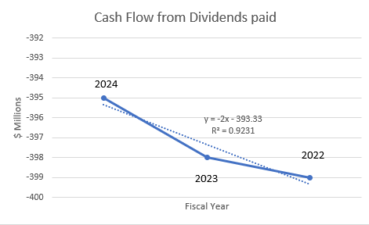

Dividends as seen in the plot above have been basically flat for the last three years from NVIDIA. Divididends have always been paid from internal cash flow for NVIDIA.

Name: Brian Morman EMBA 60

Part 4: Ratio analysis.

Subpart A: There are 15 ratios listed below (referred to as Conventional financial ratios).

15 conventional financial ratios
1 | Gross profit percentage | 8 | Financial leverage ratio
2 | Operating income percentage | 9 | Total asset turnover (TAT)
3 | Income tax rate | 10 | Return on assets (ROA)
4 | Net operating profit after taxes (NOPAT) percentage | 11 | Return on equity (ROE)
5 | Net income percentage | 12 | Days’ inventory held
6 | Interest coverage ratio | 13 | Days’ A/R outstanding
7 | Current ratio | 14 | Days’ A/P outstanding
 |  | 15 | Days’ in financing

4.A.1: Select four of the 15 conventional ratios (we will refer to these four ratios as the Conventional ratios) that you think provide the best insights to understanding the FIRM and complete the following.
- Explain why you think the four Conventional ratios you selected provide good insight to the economics of the FIRM
- Identify one of the FIRM’s competitors (denoted as Rival firm) that you think is a close rival:

  - What is the name of your Rival firm? Intel
  - Why did you select this firm? – Intel and NVIDIA are rivals in the high-end computing hardware industry. Intel has been the traditional leader in this space but have just been replaced on the Fortune 500 by NVIDIA.

- Compute the values of the four Conventional ratios for two years
  - For the FIRM and
  - For the Rival firm
- what inferences can you draw from these ratios

I chose these four ratios to get a well-rounded picture of how NVIDIA dethroned Intel as the leader in semi-conductor industry. The operating income percentage tells us how much profit a firm generates from each dollar of net sales. From 2023 to 2024 these ratios swing $0.59 in NVIDIA’s favor. Intel’s op inc% fell by 21% from 2024 into 2023. Given what we know about the state of technology in this industry, NVIDIA’s innovation was a direct driver to Intel’s loss here. With NVIDIA’s superior product offering, Intel lost in sales dramatically and likely had to give price incentives to try and drive sales.
I chose the interest coverage ratio to illustrate how each firm is able to cover their interest expenses using their operating income. In this case, the ratios swung 148 points in NVIDIA’s favor. Intel’s interest coverage has fallen to 2.6 which is an uncomfortably slim margin that explains in part, why Intel needed to do a reduction in force in 2024. Debt has become a significant factor for Intel that has forced them to find ways to reduce expense to get right their income statement.
TAT was chosen as an operating efficiency metric which tells an interesting story of how each firm is utilizing assets to generate sales. In both ’23 and ’24 Intel leads in this metric though with a greatly reduced margin. In both years Intel is performing more efficiently but is still losing in each of our other metrics. This goes to show that Intel’s problem is a product problem not an operating one.
ROE was chosen as a metric to compare the value of the equity held by the shareholders of each firm.
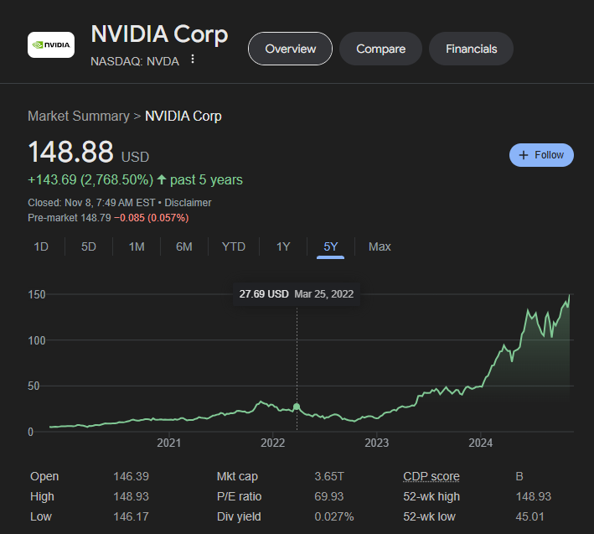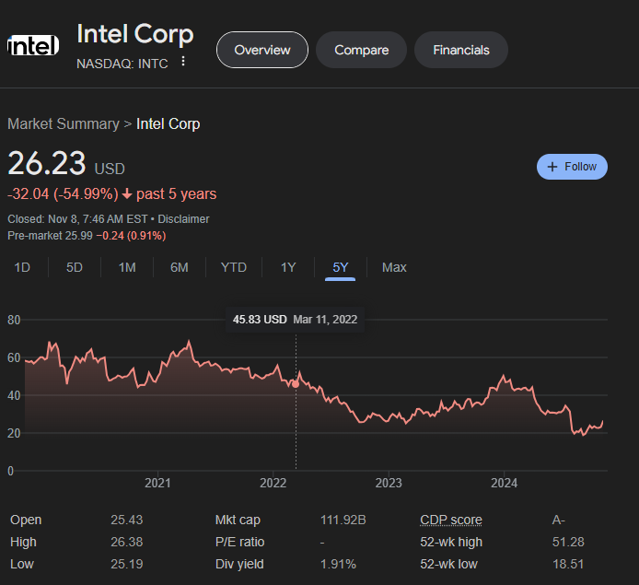

Even with the massive SE growth NVIDIA has seen due to their surging stock price, their ROE has still greatly improved. This can go to show that even with this peak in stock price, NVIDIA’s stock is not necessarily overpriced. Intel on the other hand has experienced a slow downfall in SE as their stock price has dropped from 2022 to present. Even with the drop in SE, ROE is down. Intel’s reduction in income still leads the decline ahead of the SE reaction to their income problems.
Name

Subpart B:

4.B.1: Develop two of your own ratios (not one of the 15 conventional financial ratios). Refer to these as YOUR SELECT ratios. YOUR SELECT ratios can be, but do not need to be financial in nature.

YOUR SELECT ratio #1: Research to profit ratio.

YOUR SELECT ratio #2: The bad friend ratio

4.B.2: Compute the values for YOUR SELECT Ratios for the FIRM and the competitor that you selected above for two years.

Research to profit ratio:
$$Research to Profit=\frac{R\&DExpense}{Gross Profit}$$
$$RtP NVIDIA 2023=\frac{\$8,675}{\$44,301}=19.58\%$$
$$RtP NVIDIA 2022=\frac{\$7,339}{\$15,356}=47.79\%$$
$$RtP Intel 2023=\frac{\$16,046}{\$21,539}=74.5\%$$
$$RtP Intel 2022=\frac{\$17,528}{\$26,681}=65.7\%$$
$$Bad friend ratio=\frac{Accounts payable}{Cash and cash equivalents}$$
$$Bad Friend NVIDIA 2023=\frac{\$2,699}{\$7,280}=37\%$$
$$Bad Friend NVIDIA 2022=\frac{\$1,193}{\$3,389}=35\%$$
$$Bad Friend Intel 2023=\frac{\$7,079}{\$8,578}=82.5\%$$
$$Bad Friend Intel 2022=\frac{\$11,144}{\$9,595}=116.14\%$$

4.B.3: Why do you think your SELECT ratios (a) compliment or (b) provide better insight than the 15 conventional ratios
The ratio’s I chose to create may not be inherently better than the conventional ratios, but they are different and offer unique insights that one does not get from the more conventional offerings. The research to profit ratio gives a measure of how each firm scales their research in future designs against their current profit. This gives us an understanding of how each firm values R&D at a minimum. It may also give us an understanding of the innovative skill that a group of engineers has. If one firm is spending more of their income on R&D and is not growing in the same way as its competition it may be an indication that the firm is lacking in technical skill and needs to acquire more talent to grow.
The second ratio I created is entertaining in title but does show us something about a firms strategic positioning. I call it the bad friend ratio and it is the ratio of how much a firm is holding in accounts payable to how much cash on hand. It shows us how much money the firm owes in the short term as a percentage of the cash they already have available to pay. Humorously I like to say, a low value to this ratio shows us a friend that could pay back debts but pretends the are unable to. Realistically this ratio gives us a picture of a firm’s purchasing power over its suppliers. If the firm is able to negotiate for longer payment terms, they have power over their suppliers which will pay back in the time value of money.

Name Brian Morman EMBA 60

Part 5: Option 1: Stylized pro forma financial statements – Wirtel Co. Or
Option 2: discuss how course did (or did not) affect the development of your business and/or professional skills.

Option 1: Pro forma financial statements – Wirtel, Inc. (this part of the exam is based on a stylized example - use the Excel spreadsheet on Blackboard)

The financial statements for Wirtel Co are on the Excel spreadsheet on Blackboard.

The president asks you to complete a pro forma balance sheet and income statement for year 5 using the following assumptions.

- Sales in year 5 are expected to be 14% higher than year 4.
- The gross margin percentage for year 5 is expected to be the same as year 4.
- SG&A expenses for year 5 are expected be 6% higher than year 4.
- For information on Depreciation expense, see item below related to PP&E
- Interest expense is based on bonds payable outstanding as of year 4. The interest rate is expected to be 4.5% per year.
- The average tax rate for year 5 is expected be 32% of taxable income.
- Cash is expected to remain the same.
- Gross accounts receivable is expected to be 93 and allowance for doubtful to be 6.
- Inventory is to be estimated with the assumption that inventory turnovers will be 4.0.
- Related to PP&E, there will be no disposals of PP&E during year 5, the gross PP&E are forecasted to be 450, with 315 in net PP&E.
- Income taxes payable will be the same as year 4.
- The bonds payable is the plug figure.
- There will be no changes in common stock account.
- 20% of the net income will be paid as dividends.
Requirement:
Prepare a pro forma balance sheet and income statement for Wirtel Co. on the Excel worksheet. Provide calculations or describe each of your calculations (you can round the numbers to the nearest dollar if you like).

Note: The president wants you to follow these assumptions to the letter (even if you think they might be unrealistic).

Use the Excel template on Blackboard to prepare the pro forma balance sheet and income statement for Wirtel and Cut and paste your completed pro forma from the Excel spreadsheet on the next page.

Name ______________________ | Brian Morman EMBA 60
 | Wirtel Co. Pro forma Worksheet
 |  | Complete pro forma F/S for year 5 (you can round the numbers to the nearest dollar if you like)
 | (in millions of dollars)
 | Income statement | Year 3 | Year 4 |  | Year 5 |  | Explanation / description
1 | Sales revenue | 325 | 509 |  | $580 |  | Revenue Year 4 * 1.14
2 | Less Expenses |  |  | GM | 59% |  | Gross Margin percentage year 4 and 5
3 | Cost of goods sold | 188 | 300 |  | $342 |  | Sales Revenue * gross Margin %
4 | SG&A | 44 | 57 |  | 60.4 |  | SG&A Year 4 *1.06
5 | Depreciation expense | 15 | 19 |  | 135.0 |  | Less accumulated depreciation * -1
6 | Interest | 11 | 17 |  | 6.8 |  | Year 4 bonds payable * .045
7 | Total expenses | 258 | 393 |  | 544.2 |  | Sum above 4 terms
8 | Net income before taxes | 67 | 116 |  | 36.1 |  | Sales Revenue - total expenses
9 | Income tax expense | 15 | 28 |  | 11.5 |  | .32 * Net income before tax
10 | Net income | 52 | 88 |  | 24.5 |  | Net income pretax - tax expense
11
12
13 | Balance Sheet | Year 3 | Year 4 |  | Year 5
14 | ASSETS
15 | Cash | 8 | 13 |  | 13.0 |  | Remains the same per given
16 | Accounts receivable (net) | 48 | 81 |  | 87.0 |  | Gross accounts receivable less doubtful (93 - 6) = 87
17 | Inventories | 48 | 89 |  | 85.5 |  | 4 = COGS / Inventory so: Inventory = COGS/4
18 | Total current assets | 104 | 183 |  | 185.5 |  | Sum above three terms
19 | PP&E | 387 | 409 |  | 450.0 |  | Gross PP&E Given
20 | Less accumulated depreciation | -69 | -90 |  | -135.0 |  | Net PP&E - Gross PP&E
21 | Net PP&E | 318 | 319 |  | 315.0 |  | Given
22 | Total assets | 422 | 502 |  | 501 |  | Current assets + Net PP&E
23 | LIABILITIES AND SE
24 | Income taxes payable | 11 | 21 |  | 21 |  | Given
25 | Total current liabilities | 11 | 21 |  | 21 |  | Given
26 | Bonds payable | 100 | 150 |  | 128.9 |  | Plug: Total assets - SE - current liabilities
27 | Total liabilities | 111 | 171 |  | 150 |  | Total liabilities + Bonds Payable
28 | Common stock & APIC | 160 | 160 |  | 160 |  | Given
29 | Retained earnings | 151 | 171 |  | 190.6 |  | Year 4 RE + Net Income - (0.2* Net Income)
30 | Total shareholders' equity | 311 | 331 |  | 351 |  | Common Stock &APIC + Retained Earnings
31 | Total liabilities and SE | 422 | 502 |  | 501 |  | Same as total assets

